NATIONAL

**PREPAREDNESS**

MONTH

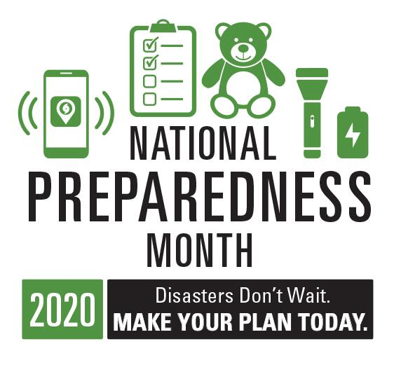

2021

B’More Prepared!

WWW.BMOREPREPARED.ORG

**Come join us for our Prepare-A-Thon Event. Get your free starter kit, your household emergency plan and other resources to keep you and your family safe.**

*Our mission is to educate families on how to make a plan, how to build their emergency kit, and support them with resources to stay prepared and connected in case of an emergency or natural disaster.*

**Where:** Cherry Hill Homes

2700 Spellman Road

**Date:** Thursday, September 16, 2021

**Time:** 10:00 a.m. – 2:00 p.m.

*Face Covering is Required*



Partnered with:

For More Information Contact Doris Johnson at 410-396-2967