The Mayor's Office of Employment Development



invites you to:

LUNCH & LEARN

Join us to learn more about our Apprenticeship Program and

how you can partner with us to support training and employment for Baltimore residents. Employers and apprentices are

welcomed.

 **MARCH 14, 2022**

 **1:00 PM - 2:00 PM**

**HOSTED VIRTUALLY VIA WEBEX**

**RSVP**

Contact [apprenticeships@oedworks.com](mailto:apprenticeships@oedworks.com) by 3/10 to confirm attendance. Webex link will be sent upon RSVP receipt.

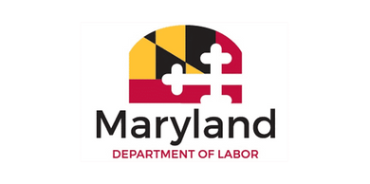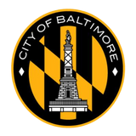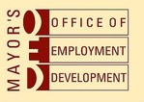

These services are supported by Coronavirus State and Local Fiscal Recovery Funds and shall be used as permitted by the federal American Rescue Plan Act of 2021 (ARPA) § 9901, Pub. L. No. 117-2, codified at 42 U.S.C.

§ 802 et seq. to support Employers and Baltimore City residents impacted by the pandemic through apprenticeship subsidies as part of an award totaling $250,000 with 0% financed from non-government sources,